TECHNICAL PROJECT REPORT

# Title of Invention / Project: Tap Game

# Team Members / Inventors:

|  |  |  |  |  |  |
| --- | --- | --- | --- | --- | --- |
| **S. No.** | **Name** | **Department** | **Designation** | **Mobile** | **E-Mail** |
| 1. | Parvinder Singh | ECE | Student | 9682670049 | desmondmiles560@gmail.com |
| 2. | Rahul Meena | ECE | Student | 6263238683 | meenamania4u@gmail.com |
| 3. | Mohit Kanu | ECE | Student | 9733220072 | mohit973322@gmail.com |
|  |  |  |  |  |  |
| 4. | Khushal Thakur | ECE | Mentor | 9646030764 | khushal.thakur@cumail.in |
| 5. | Anshul Sharma | ECE | Mentor | 9478697475 | anshulsharma.ece@cumail.in |
| 6. | Kiranjot Singh | ECE | Mentor | 9463909689 | kiranjotsingh.ece@cumal.in |
| 7. | Divneet Singh Kapoor | ECE | Mentor | 9878422653 | divneet.ece@cumail.in |

Section – 1 (IPR Related)

# Brief Abstract :

Everyone loves to play games. So we made a simple and enjoyable game. We have made this game for entertainment . It can be used in fair to earn money. When you are tired or feeling bored, then you can play this game to relax your mind.when play this game, your mind produce some chemical signals that relax your nerve cells. It is available for everyone and is not much costlier. Our project is simple but it has some drawbacks, which we are going to modify like its design, optimizing the code.

# Existing state-of-the-art and Drawbacks in existing state-of-the-art

|  |  |  |
| --- | --- | --- |
| **S. No.** | **Existing state of art** | **Drawbacks in existing state of art** |
| 1 | Made up of steel and big in size | Heavy weight |
| 2 | Circuit is big | Complex code |

# Novel/Additional modifications that you can propose to improve upon drawbacks

*(List down the features)*

* Design of the circuit
* Optimizing the code

# Advantages

* We can use it for entertainment
* Available for all age people

# Block Diagram

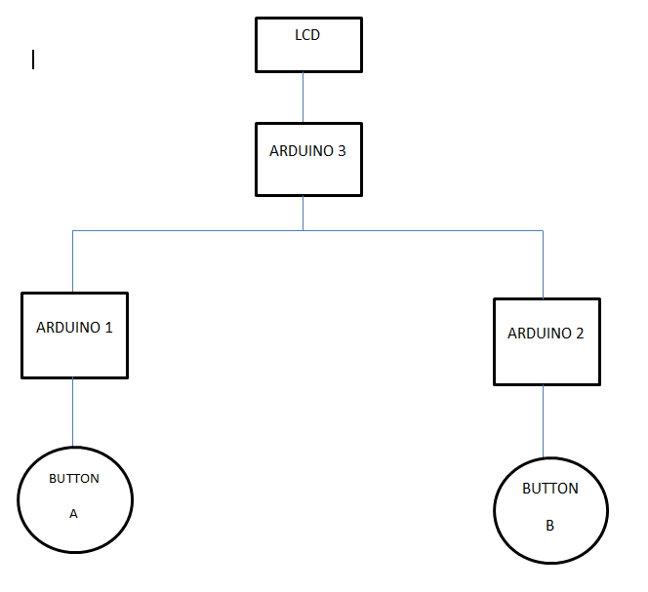

Section – 2 (Real Project)

# Materials-

* Leds – 20
* Resistor- a) 10k- 2

b) 220-20

* Wires
* LCD – 16*2
* Push button- 2
* Pcb – 2
* Potentiometer – 1
* Breadboard- 1

# Circuit Diagram

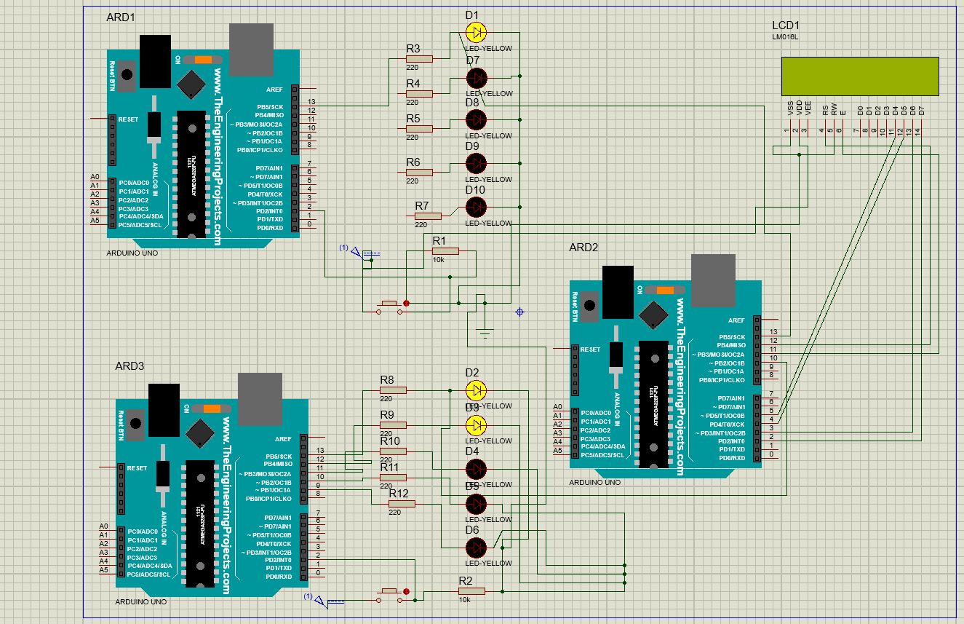

# Steps of Circuit Completion

* Firstly we collected the materials for our project.
* Then we worked for 1 week for push button coding
* Then it took 4 days for lcd code.
* Then we worked on our design of the box
* Then we worked on our circuit.
* Finally we completed our project.

# Program Code

https://github.com/edward525/BEEE.git